DRAWINGS

Total Sheets: 1

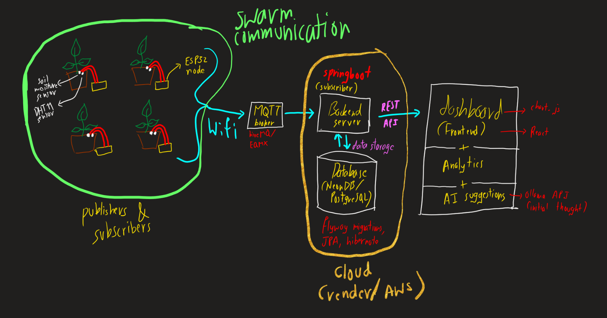

Sheet 1 of 1

